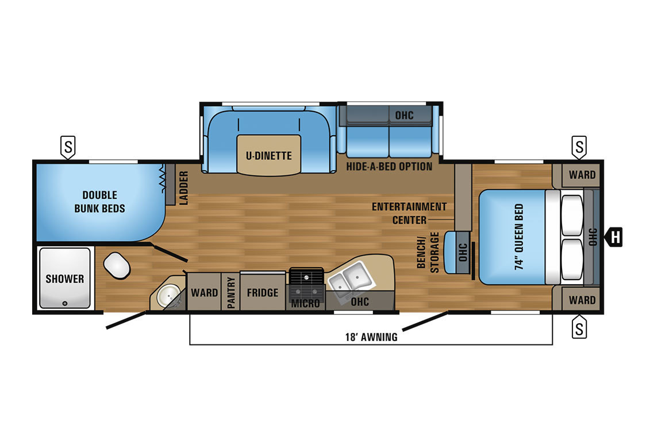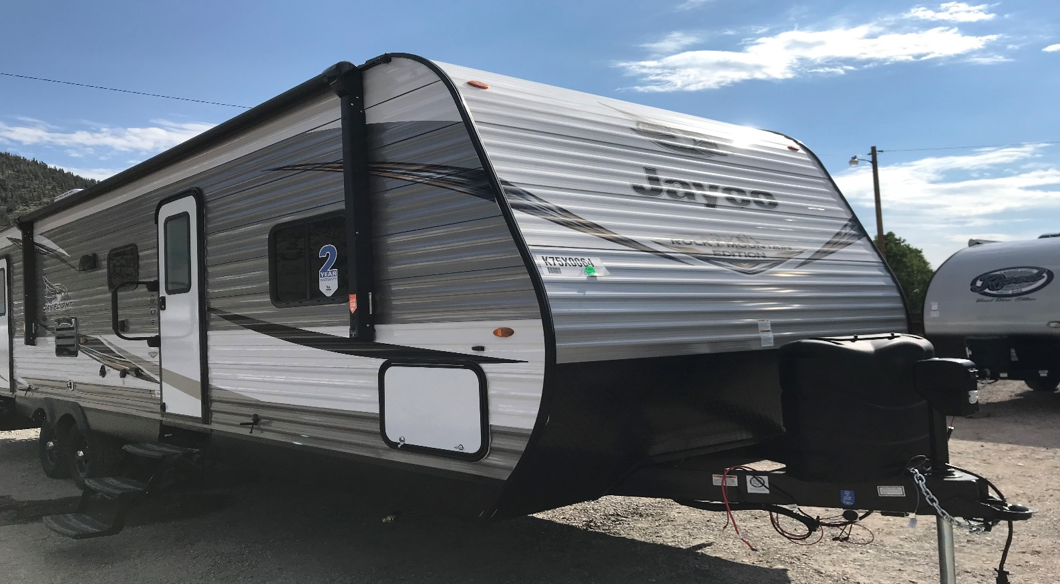

2019 JAYCO JAYFLIGHT 287 BH SW “BAJA ADDITION”
½ TON TOWABLE
TRAVEL TRAILER
SLEEPS UP TO 10: 1 QUEEN BED, 2 DOUBLE BUNKS, DINETTE AND COUCH MAKE INTO BEDS.
LENGTH 28 FEET
BALL HEIGTH 25 ½”
2 5/16” BALL
8’ Slide out
“Baja Addition” has added clearance to get you closer to nature.

Located in the Colorado Rocky Mountains, this coach comes with all the amenities for your camping experience. (dishes, sheets, blankets, 2 pillows, silverware, towels, soaps, 2 camp chairs, water hookup and disposal equipment, and trash bags)
Tow vehicle must have a working 7 pin plug. You will also need a brake controller for your vehicle, if not we have a Wireless brake controller available.
Renter must supply Liability Insurance on the towed Vehicle.
Trailer may NOT travel to Canada or Mexico.

Amenities: Air Conditioning Awning
Microwave LED lights
Solar Panel Full Shower
AM/FM Bluetooth Radio Electric Tongue Jack
Water Heater Furnace
Base Rate: $ 169.00 Per Night
Weekly Rate $1065.00 Per Week
Insurance $ 14.95 per day
Minimum 2 nights

Tax Rate: 7.5%
Refundable Damage deposit of $250.00
Unit must be returned during business hours.
Unit must be dumped grey/black/fresh water (Rainbow Grocery has dump station in South Fork)
Cleaning and Maintenance Fee $ 95.00
Propane tanks must be full upon return
There is a $25.00 non-refundable booking fee.

Suitability: Minimum age of 25
Dog Friendly (NO CATS)
Wheelchair access NO
NO SMOKING OF ANY KIND INCLUDING VAPES!! Minimum Charge $300.00
Drop Off by 10:00 AM
Pick up time 3:00 PM-5:00 PM

Options: Set Up Fee $ 200.00 (within 50 miles radius round trip)
Weight Dist. Hitch $ 30.00
Generators $ 150.00 a week or $25.00 a day
Extra Camp Chairs $ 5.00 ea.
14” Charcoal Grill $ 10.00
Propane Grill $ 10.00
Firewood Bundle $ 5.00 ea.
Wireless brake controller $ 30.00
Pet Fee $ 50.00 (NO CATS)

Cancellation Fee: Renter may receive a full refund of money collected up to 30 days before rental, 50% of money collected 30-14 days before rental, and NO refund within 14 days of rental. A $99.00 Cancellation Fee will be applied to all partial and full refunds.
Supplemental Insurance: Available upon request! Raises liability from the state minimum limits to up to $1,000,000 bodily injury liability and up to $50,000 property damage liability.

